Centre for Global Education & Queen’s University Belfast School of Education
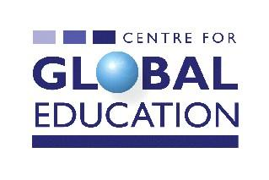
invite participation in a half-day workshop titled
Real Tools to bring about Real Change

FACILITATOR:
Jamie Kelsey-Fry

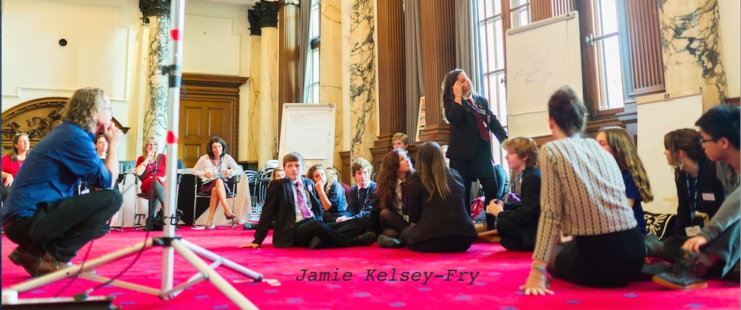

VENUE:
Room 0G/007
Queen’s University School of Education
69-71 University Street, Belfast, BT7 1HL

DATE:
Tuesday, 17 May 2016

TIME:
10.00am – 2.00pm
About the Facilitator
Jamie Kelsey-Fry is the author of the groundbreaking youth empowerment text the Rax Active Citizenship Toolkit, contributing editor to award winning global justice magazine the New Internationalist, a regular pundit on mainstream media with 20 years experience as a teacher and as an activist. He promotes a form of learning that enables young people to make the journey from political literacy to political agency and uses cutting edge stunts, actions and interventions that have a measurable impact on the real world.

Check out some of Jamie’s media appearances here:
https://www.youtube.com/watch?v=OaM4SV6o4I4
https://www.youtube.com/watch?v=TVNcg91SP1k&feature=youtu.be
http://jamiekelseyfry.org/radio-tv/
https://www.youtube.com/watch?v=Df_BzXBvpWw

About the workshop
This will be a practical session on ways to engage young people in authentic active citizenship projects, based on the facilitator’s more than 20 years of being engaged in active citizenship. The workshop will include ideas for media stunts, culture jamming and being media savvy.

There will be a particular reference to acting on global issues which will tie in with New Internationalist magazine to which Jamie has been a contributing editor. Participants will leave the workshop with dynamic and practical ideas for engaging young people in actions on global issues.

Target Groups
- Global / Development Educators
- Community sector workers and volunteers
- Educators who work with young people on global issues in formal and informal settings
- Activists on green, social justice, economic justice, human rights and equality issues.

Centre for Global Education
The Centre for Global Education was established in 1986 to provide education services that enhance awareness of international development issues. The Centre provides learners with the skills, values, knowledge and understanding necessary to facilitate action that will contribute to poverty eradication both locally and globally.

Centre for Global Education
9 University Street
Belfast
BT7 1FY

Tel: (0044) 2890 241879
E-mail: stephen@centreforglobaleducation.com
Web: www.centreforglobaleducation.com

To register please complete the form below and return it to: Stephen McCloskey, E: stephen@centreforglobaleducation.com. Places are strictly limited.

Registration Form
To register for the workshop please complete and return this form with your payment to the address below as soon as possible as places are reserved on a ‘first come first served basis’. You can complete the form electronically and return it by e-mail to stephen@centreforglobaleducation.com and send your payment by post.
Name:
Organization:
Address:
Tel:
Email:
Fees (light lunch included): £15.00 €20.00
Please make cheques/postal orders payable to ‘Centre for Global Education’.
Please send this registration form to: Stephen McCloskey, Centre for Global Education, 9 University Street, Belfast, BT7 1FY
For further information email: stephen@centreforglobaleducation.com

FUNDED BY:
This event is also being supported as part of the Five Nations Citizenship Network (NI)

